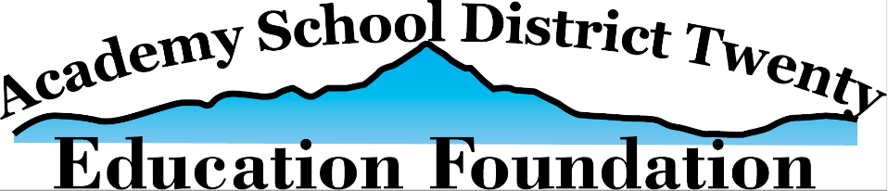

Academy D20 Education Foundation Future Educator Scholarship 2024
Complete Applications are due by Friday, April 12, 2024, at 4:00 p.m.
Candidates can submit their application virtually through MS Forms using this link (https://forms.office.com/r/GkifLT6heb) or, if you prefer to submit this packet physically, please deliver the complete application (including attachments) to the District Central Office (EAC) in care of: Dr. Jeremy Koselak, 1110 Chapel Hills Drive, Colorado Springs, CO 80920 by Friday, April 12, 2024, at 4:00 p.m.
Name:
Your High School:
Your District Email Address (for contact by the D20 Education Foundation only):
Your Personal Email Address (for contact by the D20 Education Foundation only, after graduation):
Phone Number (for contact by the D20 Education Foundation only):

Confirming Eligibility:
Check all boxes that apply. You must meet all the requirements in order to be eligible for this scholarship.
_________ My GPA is at least a 3.5
_________ I will be attending a 2 or 4-year accredited American university or college.
_________ I plan to become a teacher/educator for my career.
_________ I will be available for an in-person interview on April 24 - 26, 2024 (between 3 and 6 pm).
_________ I have not received a full-ride scholarship to my chosen university or college.
_________ I have not applied for the D20 Education Foundation CTE Scholarship, nor the D20 Education Foundation Academic Scholarship.

Questions:
- Share your experiences related to teaching, tutoring, mentoring, serving others, and/or leading, and how that has impacted you and others.

- What are your future plans, specifically related to becoming an educator?

Essay Question: What 1 educator in your K-12 education journey has impacted you the most, made you want to be an educator, and why? (up to 1500 words)
Required Attachments:
- 2 Letters of Recommendation (from a non-relative)
- Copy of your High School Transcript from Infinite Campus (unofficial copy is acceptable)

